Table of Contents

TurboCASH5-2025-Release Candidate 4 1

Installation 1

Needs updates in next release - TurboCASH5-2025-Release-Candidate-5-setup.exe - To Update install source 1

Outdated Help file (EngHelp.chm) 1

Fixes in progress - Debtor Statements / Creditor Remittance Advices and Age analysis reports cut-off Description text 1

Folders not included 1

Bank import - Shows the Reconcile button and Match log tab not correct 2

Outstanding : Debtor Statements / Creditor Remittance Advices and Age analysis reports SREFERENCE cut off text 2

MSSQL ERROR - Budget 4

# TurboCASH5-2025-Release Candidate 4

## Installation

**Install file :** TurboCASH5-2025-Release-Candidate-4-setup.exe =[***Download from Sourceforge***](https://sourceforge.net/projects/turbocash/files/shareware/TurboCASH5-2025-Release-Candidate-4-setup.exe/download)

**FIXED Install Script** - Install no overwrite message displayed in a clean install. **NOTE**: This seems to be correct - When installing TurboCASH5-2025-Release-Candidate-4 in the same existing directory you may receive two messages:

1. **Directory exists** - Confirm to install in the existing directory or select no to choose a different directory.
2. **Set of Books exists** - Confirm to keep the existing Set of Books or choose to overwrite (replace the files in the Set of Books.

## Needs updates in next release - TurboCASH5-2025-Release-Candidate-5-setup.exe - To Update install source

Compile of TutboCASH5-2025-Release-Candidate-4 not compiled on TC5-2025-MERGE-Install -Source-Release-Candidate-3.7z - Lots of fixes were done and hours spent on these between 18 December 2024 and 25 December 2025.

### Outdated Help file (EngHelp.chm)

* Release Candidate 3 source = Wednesday, 25 December 2024 - 03:55:54 - osFinancials5/TurboCASH5 - Business Class - Help
* Help file outdated = Wednesday, 18 December 2024 - 06:23:01 - osFinancials5/TurboCASH5 - Business Class - Help

### Fixes in progress - Debtor Statements / Creditor Remittance Advices and Age analysis reports cut-off Description text

* Firebird databases - Debtor Statements / Creditor Remittance Advices and Debtor Age analysis / Creditor Age analysis reports not updated with Fixes to Descriptions not printing fully (Characters cut-off) in nounicode=FALSE setting (Unicode enabled for most users). References Such as the Document number and references entered in batch entry screens - still n cuts-off only in Firebird databases. Need to add similar sgl "cast(messages.SDescription as varchar(255)) as SDESCRIPTION_1 " for the SREFERENCE - I may need some guidance and pointers to fix these.
* MSSQL databases - Prints correct in all these reports - Prints the full References and Descriptions.

### Folders not included

execute\localfiles\dbname folder not included.

### Bank import - Shows the Reconcile button and Match log tab not correct

Neet to check the configuration / activation of the bank import plugin. The **Reconcile** button should not be displayed as in osFinancials5.1.0.227.

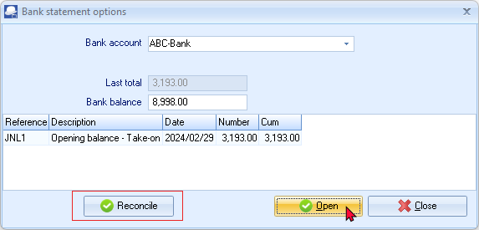

The Match log may display incorrect data

## Outstanding : Debtor Statements / Creditor Remittance Advices and Age analysis reports SREFERENCE cut off text

In **Firebird** Databases, the Reference only displays 7 Characters - not the full document number or reference as entered in the Reference field of batch entry screens. The Descriptions were fixed in TurboCASH5-2025-Release-Candidate-3 (Also replicated in osFinancials5-MERGE-7)

Replicated in **nounicode=FALSE** setting (installs for most users)

In **MSSQL** Databases, it displays the full characters and does not replicate these Reference and Description labels not fully printed.

Example of Debtors statement - Outstanding. **NOTE** the Debtor statement prints the full characters, while the Debtor Age analysis and Creditor Remittance advices - Outstanding and Creditors Age analysis reports, replicates the same issues with the Reference not printing in Firebird databases fully.

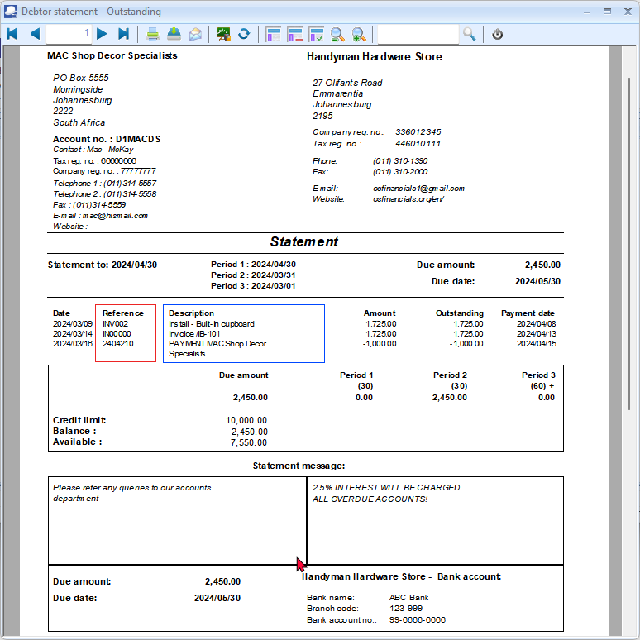

The Descriptions is fixed in TurboCASH5-2025-Release-Candidate-3 (Also fixed in osFinancials5-MERGE-7)

**FIXED : Debtor Statements / Creditor Remittance Advices and Age analysis reports cut off text**

On Debtors statements, the TrExpression26 = TRANSACTDETAIL.SDESCRIPTION_1 displays only 20 characters if **nounicode=FALSE** setting also in Data configuration and on printed report.

If the **nounicode=FALSE** setting is set to **nounicode=TRUE**, the full descriptions on Debtor statements will be printed.

Similar Descriptions issues were replicated in the following reports:

**Debtors**

* **Debtor statements** 
  + **Location :** plug_ins\reports\systemreports\TRN_160\TRN_1090 \TRN_1090 - [Debtor statement](hnd-topic://8c274d3dfaf9474a8b36fcd354ebe6d4)
  + **Location :** plug_ins\reports\systemreports\TRN_160\TRN_1090 \TRN_906552 - [Debtor statement - Outstanding](hnd-topic://624c8532a86f453d9aec827af9a9f08c)
* **Debtors - Age analysis (Rreports)**
  + **Location** : plug_ins\reports\userreports\TRN_160\TRN_906142 - [Balances detail](hnd-topic://467b578385934c7395da089ca7bdc143)
  + **Location** : plug_ins\reports\userreports\TRN_160\TRN_906143 - [Balances detail history (open item)](hnd-topic://f937cb8c032447268d5d14e5e366f303)
  + **Location** : plug_ins\reports\userreports\TRN_160\TRN_906147 - [Balances](hnd-topic://8d6c809d62b44953b17c4baab02fb8d3)

**Creditors**

* **Creditor remittance advices** 
  + **Location :** plug_ins\reports\systemreports\TRN_161\TRN_1090 \1089 - [Creditor remittance advises](hnd-topic://325c635b8ee44449aef645639a90c5d4)
  + **Location :** plug_ins\reports\systemreports\TRN_161\TRN_1090 \TRN_906551 - [Creditor remittance advises - Outstanding](hnd-topic://8265d046049e4684aadf6763c5c8496f)
* **Creditors - Age analysis (Reports)**
  + **Location** : plug_ins\reports\userreports\TRN_160\TRN_906142 - [Balances detail](hnd-topic://73f91da0fef543d89acb7f5225436e1c)
  + **Location** : plug_ins\reports\userreports\TRN_160\TRN_906143 - [Balances detail history (open item)](hnd-topic://7e429ef754e743b19015a7f1d014a1d9)
  + **Location** : plug_ins\reports\userreports\TRN_160\TRN_906147 - [Balances](hnd-topic://e89f15980f1f4e48aafa51046a750c5a)

Added cast message field length to Descriptions in TRANSACTDETAIL

|  |
| --- |
| SELECT  cast(transact.FAmount as decimal(12,2)) p1,  transact.*,Account.*,  cast(messages.SDescription as varchar(255)) as SDESCRIPTION_1  FROM transact  LEFT OUTER JOIN account  ON (transact.WAccountID = account.WAccountID)  join Messages on (transact.WDescriptionid = messages.WMessageID) |

# MSSQL ERROR - Budget

*Incorrect syntax near 'a'.*